Task: Wap to run 3 threads simultaneously
public class MultiThreadingDemo {
public static void main(String[] args) {
Thread t1 = new Thread(()->{
System.out.println("Good morning");
});

Thread t2 = new Thread(()->{
System.out.println("Good Afternoon");
});

Thread t3 = new Thread(()->{
System.out.println("Good Evening");
});

t1.start();
t2.start();
t3.start();

}
}

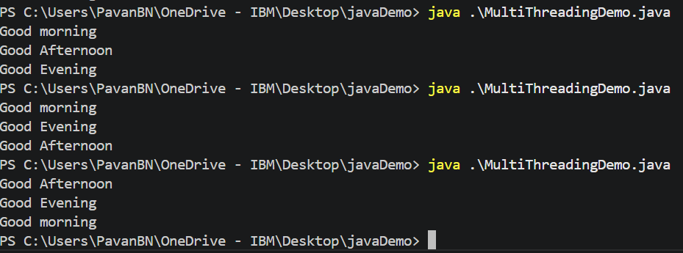
Task2: in the above program make
T1 -> sleeps for 2 sec
T2 -> sleeps for 1 sec
T3 -> sleeps for 0 sec
&
Task 3: In the same prog give the name as
T1 -> morning
T2 -> afternoon
T3-> evening
// import java.util.concurrent.Exe;

public class MultiThreadingDemo {
public static void main(String[] args) throws InterruptedException {
Thread t1 = new Thread(() -> {
try {
Thread.sleep(0);
System.out.println("Good morning");
} catch (InterruptedException e) {
System.out.println(e.getMessage());
}
},"morning");

Thread t2 = new Thread(() -> {
try {
Thread.sleep(1000);
System.out.println("Good Afteroon");
} catch (InterruptedException e) {
System.out.println(e.getMessage());
}
},"afternoon");

Thread t3 = new Thread(() -> {
try {
Thread.sleep(2000);// we can also simply remove this line
System.out.println("Good Evening");
} catch (InterruptedException e) {
System.out.println(e.getMessage());
}
});
t3.setName("evening");

t1.start();
t2.start();
t3.start();

t1.join();
t2.join();
t3.join();

System.out.println(t1.getName() +" "+t2.getName()+" "+t3.getName());

}
}

Task 4: in the same code set
T1 -> max priority
T2 -> normal priority
T3 -> low priority

public class MultiThreadingDemo {
public static void main(String[] args) throws InterruptedException {
Thread t1 = new Thread(() -> {
try {
// Thread.sleep(0);
System.out.println("Good morning");
} catch (Exception e) {
System.out.println(e.getMessage());
}
},"morning");

t1.setPriority(Thread.MAX_PRIORITY);

Thread t2 = new Thread(() -> {
try {
// Thread.sleep(1000);
System.out.println("Good Afteroon");
} catch (Exception e) {
System.out.println(e.getMessage());
}
},"afternoon");
t2.setPriority(Thread.NORM_PRIORITY);

Thread t3 = new Thread(() -> {
try {
// Thread.sleep(2000);// we can also simply remove this line
System.out.println("Good Evening");
} catch (Exception e) {
System.out.println(e.getMessage());
}
});
t3.setName("evening");
t3.setPriority(Thread.MIN_PRIORITY);

t1.start();
t2.start();
t3.start();

t1.join();
t2.join();
t3.join();

System.out.println(t1.getName() +" "+t2.getName()+" "+t3.getName());

}
}

Task 5: Wap to run threads ina a loop of 1 to 20
public class Main {
public static void main(String[] args) {
for (int i = 0; i <= 20; i++) {
final int num = i;
Thread t = new Thread(() -> {
try {
Thread.sleep(1000);
// Thread.dumpStack(); // <-- here
System.out.println("Thread - " + Thread.currentThread().getName() + " i = " + num);
} catch (InterruptedException e) {
System.out.println(e.getMessage());
}
});

t.setName(i + "");
t.start();
}

}
}

Task 6: Check for isalive status of a thread
// import java.util.concurrent.Exe;

public class MultiThreadingDemo {
public static void main(String[] args) throws InterruptedException {
Thread t1 = new Thread(() -> {
try {
// Thread.sleep(0);
System.out.println("t-"+ Thread.currentThread().getName() + " Good morning");
} catch (Exception e) {
System.out.println(e.getMessage());
}
},"morning");

t1.setPriority(Thread.MAX_PRIORITY);

Thread t2 = new Thread(() -> {
try {
// Thread.sleep(1000);
System.out.println("t-"+ Thread.currentThread().getName() + " Good Afteroon");
} catch (Exception e) {
System.out.println(e.getMessage());
}
},"afternoon");
t2.setPriority(Thread.NORM_PRIORITY);

Thread t3 = new Thread(() -> {
try {
Thread.sleep(3000);// we can also simply remove this line
System.out.println("t-"+ Thread.currentThread().isAlive() + " Good Evening");
} catch (Exception e) {
System.out.println(e.getMessage());
}
});
t3.setName("evening");
t3.setDaemon(true);
t3.setPriority(Thread.MIN_PRIORITY);

t1.start();
t2.start();
t3.start();

t1.join();
t2.join();
t3.join();

// System.out.println(t1.getName() +" "+t2.getName()+" "+t3.getName());
System.out.println("Main thread finished");
System.out.println(t1.isAlive());

}
}

Task 7: Wap to demonstrate synchronized
public class SynchronizedDemo {

public static void main(String[] args) throws InterruptedException {
Counter c1 = new Counter();

Thread t1 = new Thread(c1);
Thread t2 = new Thread(c1);

t1.start();
t2.start();

t1.join();
t2.join();

c1.printCount();
}

}

class Counter implements Runnable {
int counter = 0;

public synchronized void increment() {
counter++;
}

public void printCount(){
System.out.println(counter);
}

@Override
public void run(){
for(int i=0;i<1000;i++){
this.increment();
}
}

}

Task 8: Wap to demonstrate exception
public class ExceptionDemo {
public static void main(String[] args) {
try{
throw new RuntimeException("Runtime exception");
}catch(RuntimeException e){
System.out.println(e.getMessage());
}catch(Exception e){
System.out.println(e.getMessage());
}finally{
System.out.println("Done");
}
}
}

